RESULTS AND OUTCOME

5.1 Overview
The RADMAP project, kind of proved the feasibility of a GPS enabled real-time radiation mapping system using Raspberry Pi-5, plus a Gamma Spectrometer together with a GlobalSat BU-353N GPS Receiver, and then add environmental sensors and a live camera feed, kind of monitoring in parallel. During the internship we built a full backend pipeline to gather, handle, display, and study radiation data, basically all in real time.
One of the main achievements was really more about getting the 2D radiation heatmap to work properly, like mapping radiation intensity with GPS coordinates in a way that was accurate, even if it took some iterations. The system then showed radiation levels via moving, dynamic color gradients, so it was easier to spot the radiation hotspots fast. At the same time it still reported radiation counts, peak channels, and basic environmental parameters like temperature and humidity which mattered a lot.
And because conventional 2D mapping has that kind of limitation, a 3D Digital Twin was researched and then built by tying together GPS coordinates, SLAM based mapping, and live camera feedback. This ended up giving a more intuitive spatial representation of the radiation distribution, and in the long run it also set up the groundwork for future localization of radioactive sources, which is kind a the next step.
The Gamma Spectrometer (CNSPEC MCA) was successfully integrated with the Raspberry Pi-5 and experimentally validated using Cobalt-60 (Co-60) and Cesium-137 (Cs-137) radioactive sources. The detector accurately identified radiation counts, peak channels, and energy spectra, confirming the reliability of the developed system.
Real time backend architecture was put in place to sync radiation data, GPS information, environmental parameters and camera streams together into one processing pipeline. That backend keeps acquisition, storage and visualization efficient too, while also leaving the door open for future AI features, and even autonomous navigation.
On top of that, a color grading algorithm inspired by night vision imaging was developed. The goal was to overlay radiation intensity directly onto the live camera feed. Different radiation levels were shown with a set of color gradients, it improved the real time visualization quite a lot, and honestly made situational awareness feel clearer in the moment.
Finally, a 3D prototype model of the RADMAP system was designed for future deployment, validating and testing the device. Based on the successful outcomes of the project, the work got funding approval from Dr. Abhishek Yadav and the Director, Amity Institute of Nuclear Science and Technology (AINST) for further enhancement, hardware integration , and next generation development.

5.2 Prototype Implementation
The final RADMAP prototype brings together the main hardware components into this kind of compact , portable setup. It does real time acquisition of radiation counts along with GPS coordinates, temperature, humidity and various environmental details. After that the gathered data go through the Raspberry Pi-5 backend where they are processed to create synchronized radiation maps and to really help with Digital Twin visualization. Overall it kind of ties everything in one place, without being too bulky.
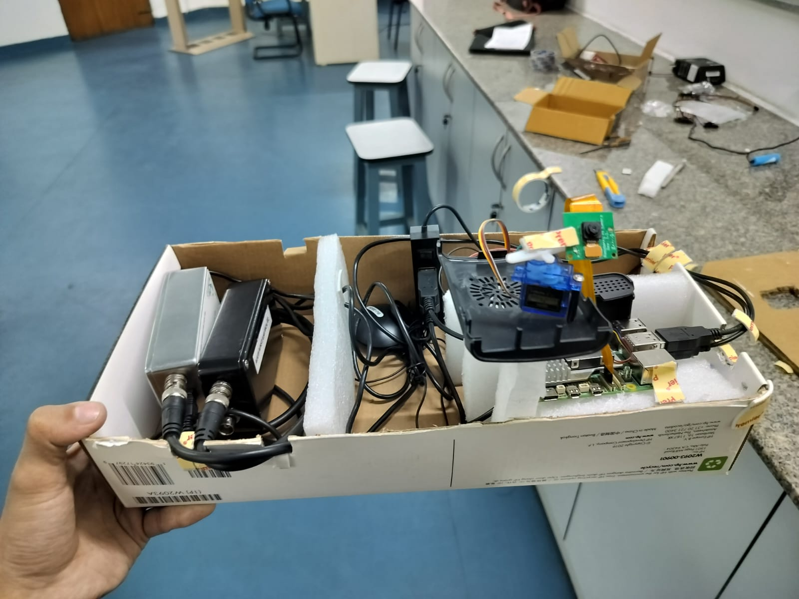
Figure 9: Final RADMAP Prototype Model

5.3 GPS Data Acquisition Results
The GlobalSat ‘BU-353N’ GPS receiver managed to give continuous geo location and environmental telemetry while the system was in operation, more or less. The GPS data that was collected got synchronized with radiation readings so, in the end, accurate geospatial radiation maps could be generated. The GlobalSat ‘BU-353N’ was then successfully put together with the Raspberry Pi-5, to capture real time geographical location info. Throughout operation the setup kept logging latitude, longitude, UTC time, satellite details, speed, and the positioning precision using HDOP and PDOP, via NMEA communication.
Parameter | Observed Value
GPS Receiver | GlobalSat BU-353N
Communication Port | COM8 (Prolific PL2303GC USB Serial)
Baud Rate | 4800 bps
Date | 18th June, 2026
UTC Time | 12:37:50
Latitude | 28° 32.7622′ N
Longitude | 77° 19.9810′ E
GPS Fix Status | 3D Fix
Speed | 1km/h
Direction (Course) | 77.99°
Satellites in View | 10
Satellites in Used | 5
HDOP | 1.57
PDOP | 1.85
Data Protocol | NMEA 0183 (GPGGA, GPRMC, GPGSV, GPGSA)
Communication Interface | USB Serial (PL2303GC)

Table 3: Real-Time GPS Receiver Output (GlobalSat BU-353N)

6.4 Final Integrated System Metrics
The integrated system successfully synchronized radiation measurements with GPS coordinates and environmental parameters. These combined metrics were used to generate the 2D radiation heatmap and support the 3D Digital Twin visualization.
Parameter | Value
Source | Cobalt-60 (Co-60)
Device (Status) | LIVE
Elapsed Duration | 38S
Total Counts | 3,935
Radiation Intensity (Area) | 3,935
Count Rate | 103.6 CPS
Peak Channel | 92
Max Counts (at Peak) | 45

Table 4: Session Summary of Gamma Spectrometer

Channel Number | Count | Relative Prominence
92 | 45 | Primary Photo peak
127 | 27 | Secondary
148 | 24 | Secondary
168 | 19 | Minor
190 | 11 | Minor
212 | 13 | Minor
240 | 26 | Secondary
274 | 13 | Minor

Table 5: Detected Photo peaks (Channel-wise) of Gamma Spectrometer

